Welcome to wdxLibrary! Enjoy it!
wdxLibrary is a Javascript library that works over OpenXML4J and ooxml-schemas
and allows to create .docx files using their functionality.
It's designed to get report documents with special formatting from ARIS Platform products.
This document generated using wdxLibrary
Copyright (c) 2017 Nikita Martyanov
https://github.com/kitmarty/wdxLibrary

Run without special settings
Текст кириллицей
Italic
Bold
Italic&Bold
Single underline Wavy heavy underline^{superscript}
All letters are capitals _{subscript}
All letters are small capitals
Strikethrough text
Highlighted text
Additional info about properties and constants you can find in wdxLibrary.js.
Also you can read ECMA standarts and explore ooxml-schemas-x.x.jar for more functionality. It's easy to add to this library special formatting you need.
Below you can find examples of interesting formatting such as footnotes, endnotes, embedded files etc.

This section has 3 columns and landscape orientation.
Text in the second column
Text in the third column

Text in paragraph with a footnote.
Text in paragraph with an endnote. Description of this endnote you can find in the end of the document.
Endnotes numbering format is upper letter. It's defined in the section properties

This section has a header.
This text outputs after the header has been put in the file.
This section also has a footer which contents page field with special formatting.

This section demonstrates tables.
This section doesn't have header and footer.
Colored text in cell | This table has two cells. Table is 100% width of the page, and cells are 50% width of the table.  This cell has #AAAAAA fill color.

In the previous section I've added a bookmark to check this function.
Hyperlink to the bookmark of the previous section
Next hyperlink is external. Project page will be opened in default browser.
https://github.com/kitmarty/wdxLibrary/
There is an example of multilevel numbered (and bulleted) list below.
- First level of the list. Upper Roman numbering format.
  - Second level of the list (decimal numfmt)
  - Second level of the list
    - Third level of the list (bullets)
    - Third level of the list (bullets)
- First level of the list

There is an embedded file below (double click). Thumbnail generates on the fly using Java libraries. You can change it for ordinary MS Word icon but I don't know anything about copyrights that's why I've done this weird solution.
In this section you also can find examples of graphic output.
The header of the section contents wdxLibrary logo and the page body contents picture of context model.
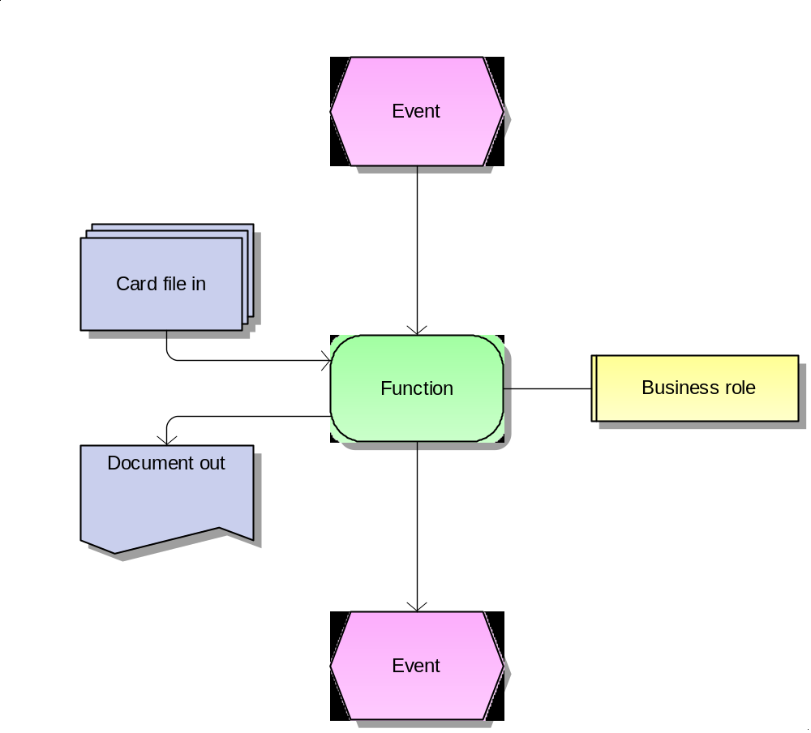

This section has the same header as in the previous section.
wdxLibrary also allows you to define 'native' styles of the document. There is a paragraph below where the 'native' style is applied.
Text with the style that calls 'Custom style by wdxLibrary'

footnote description without special formatting
endnote description without special formatting

